## Launch the program

To launch the program, you need to use CMD to enter the path where the source code is, and then type in the following code.

For task1, task2, and task3:

1. javac JungleParty.java
2. java JungleParty

The program will start like the following pictures:

Task1: Task2:

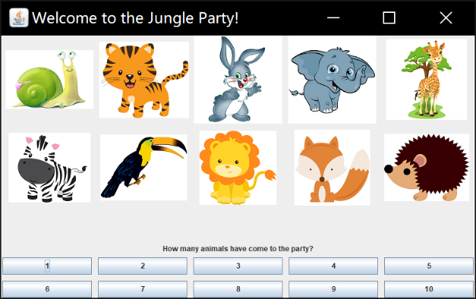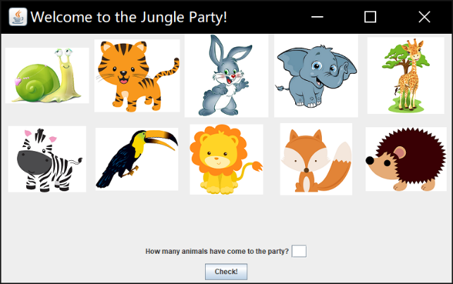

Task3:

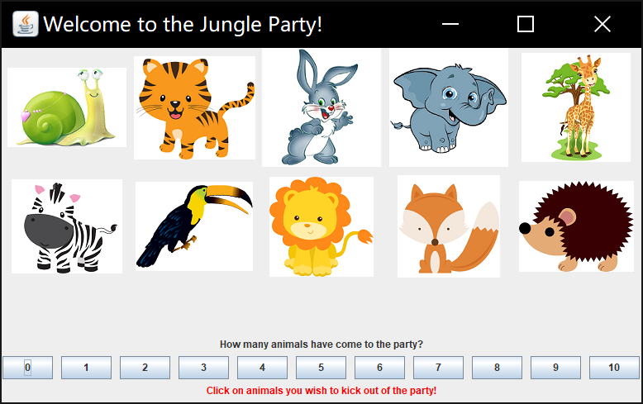

For extra credit:

1. javac JungleParty.java
2. java JungleParty x (x stands for a number between 10 and 20, it represents the number of images which will be displayed firstly)

The program will start like the following picture:

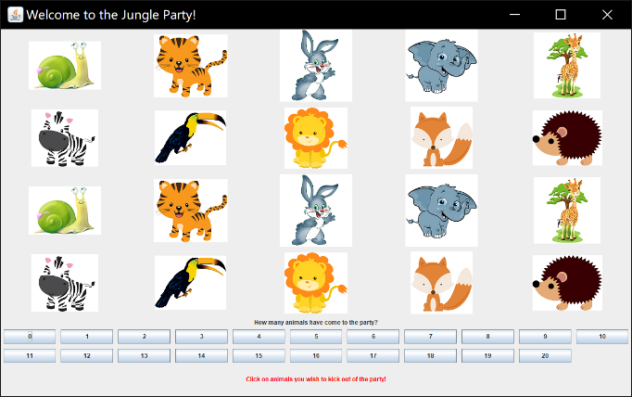

## Start to practice

After you launch the program, you can start to practice

For task1, you can input a number to check whether the number you input is equal to the number of pictures of animals. If you are correct, the program will change the number of picture to between 1 and 10 so that you can practice again.

For task2, you can click the buttons at the bottom of the program. If you are right, the program will change the number of pictures to between 1 and 10.

For task3, an additional function is added to the program so that you can simply click on one of the pictures to make it disappear and the number of pictures will change correspondingly. After you click on a picture, the program will change like the following picture.

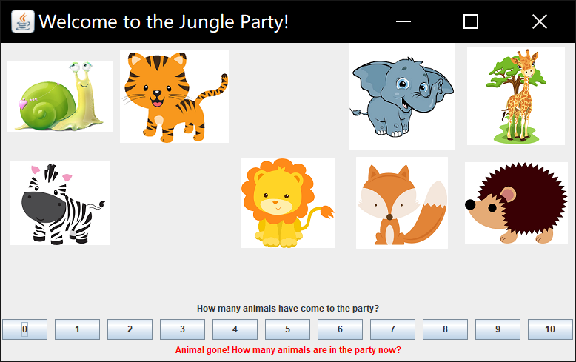

For extra credit, the program will launch with the number of pictures you input from the CMD command, then the program will function like specified in task 3, but the random number of pictures is between 0-15. If you click on the right number, the program will change like the following picture.

